Home Work 6

1.

#include<stdio.h>

#include<math.h>

int fact(int n)

{

int factn=1, i;

for(i = 1; i<=n; i++)

{

factn \*= i;

}

return factn;

}

int main()

{

int n, i;

double x, sum = 1.0;

printf("Please provide the value of x: ");

scanf("%lf", &x);

printf("Please provide the value of n : ");

scanf("%d", &n);

printf("The values of n = %d and x = %lf\n", n, x);

for(i=1; i<=n; i++)

{

sum += (pow(x, n)\*1.0)/(fact(n)\*1.0);

}

printf("The value of the sum upto %dth term is %lf\n\n", n, sum);

}

Output:

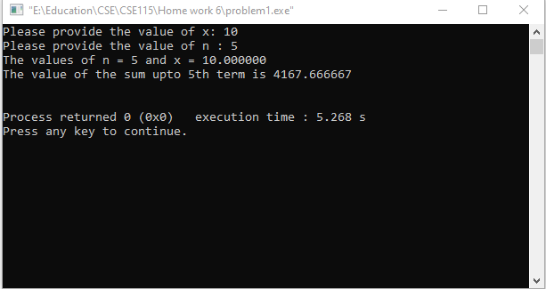

2.

#include <stdio.h>

int main()

{

int arr1[]={20,11,78,34,51,4,101,29,90,67};

int length=sizeof(arr1)/sizeof(arr1[0]);

int min=arr1[0];

int index=0;

for(int i=0;i<length;i++)

{

if(min>arr1[i])

{

min=arr1[i];

index=i;

}

}

printf("Smallest element of the array: %d\n",min);

int temp=arr1[0];

arr1[0]=arr1[index];

arr1[index]=temp;

printf("After swapping\n");

for(int i=0;i<length;i++)

{

printf("%d ",arr1[i]);

}

return 0;

}

Output:

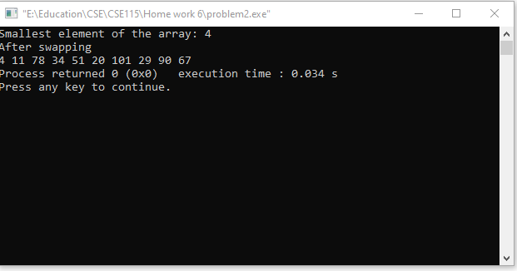

3.

#include <stdio.h>

int main()

{

float arr1[]={20.2,11.05,78.1,34.9,51.11,4.0,101.8,29.03,90.42,67.6};

int length=sizeof(arr1)/sizeof(arr1[0]);

float sum=0;

for(int i=0;i<length;i++)

{

sum+=arr1[i];

}

float average=sum/length;

printf("Average: %f",average);

printf("\nNumbers less than calculated average:\n");

for(int i=0;i<length;i++)

{

if(average>arr1[i])

{

printf("%.2f ",arr1[i]);

}

}

return 0;

}

Output:

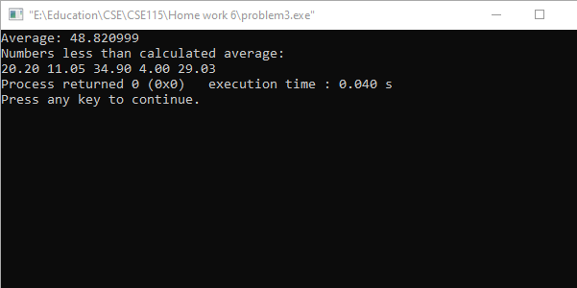

4.

#include <stdio.h>

int main()

{

int arr1[5][5],i,j,temp;

printf("Enter any 5x5 matrix:");

for(i=0;i<=4;i++)

{

for(j=0;j<=4;j++)

{

scanf("%d",&arr1[i][j]);

}

printf("\n");

}

printf("original matrix:\n");

for(i=0;i<=4;i++)

{

for(j=0;j<=4;j++)

{

printf("%d ",arr1[i][j]);

}

printf("\n");

}

int k=4,m=0;

for(i=0;i<=4;i++)

{

for(j=0;j<=4;j++)

{

if (i==j)

{

temp=arr1[i][j];

arr1[i][j]=arr1[k][m];

arr1[k][m]=temp;

m++;

}

}

}

printf("\n\nAfter swapping:\n");

for(i=0;i<=4;i++)

{

for(j=0;j<=4;j++)

{

printf("%d ",arr1[i][j]);

}

printf("\n");

}

return 0;

}

Output:

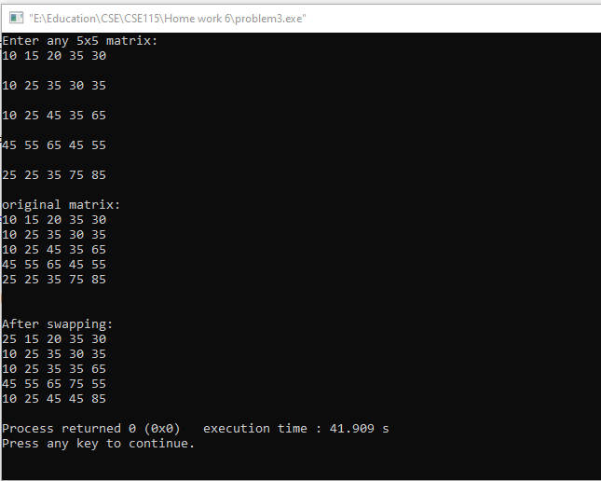

5.

#include <stdio.h>

int main()

{

int array[5][5];

for(int i=0;i<4;i++){

for(int j=0;j<5;j++){

scanf("%d",&array[i][j]);

}

}

int calculate=0;

for(int i=0;i<4;i++){

for(int j=0;j<5;j++){

if(array[i][j]==0){

calculate++;

}

}

}

printf("Zeros in the matrix is %d", calculate);

return 0;

}

Output:

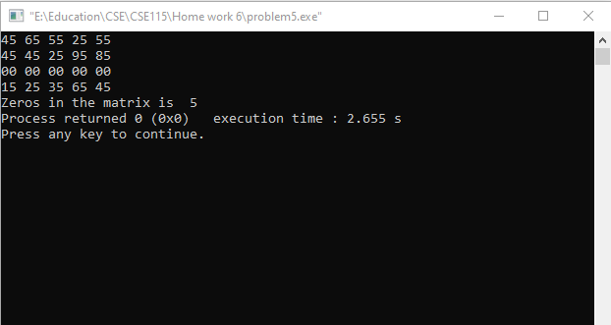

6.

#include <stdio.h>

int main()

{

int calculate[5][5];

for(int i=0;i<5;i++){

for(int j=0;j<5;j++){

scanf("%d",&calculate[i][j]);

}

}

int add=0;

for(int i=0;i<5;i++){

for(int j=i;j<5;j++){

if(i==j){

add+=calculate[i][j];

break;

}

}

}

printf("Sum of the diagonal elements matrix is %d", add);

return 0;

}

Output:

